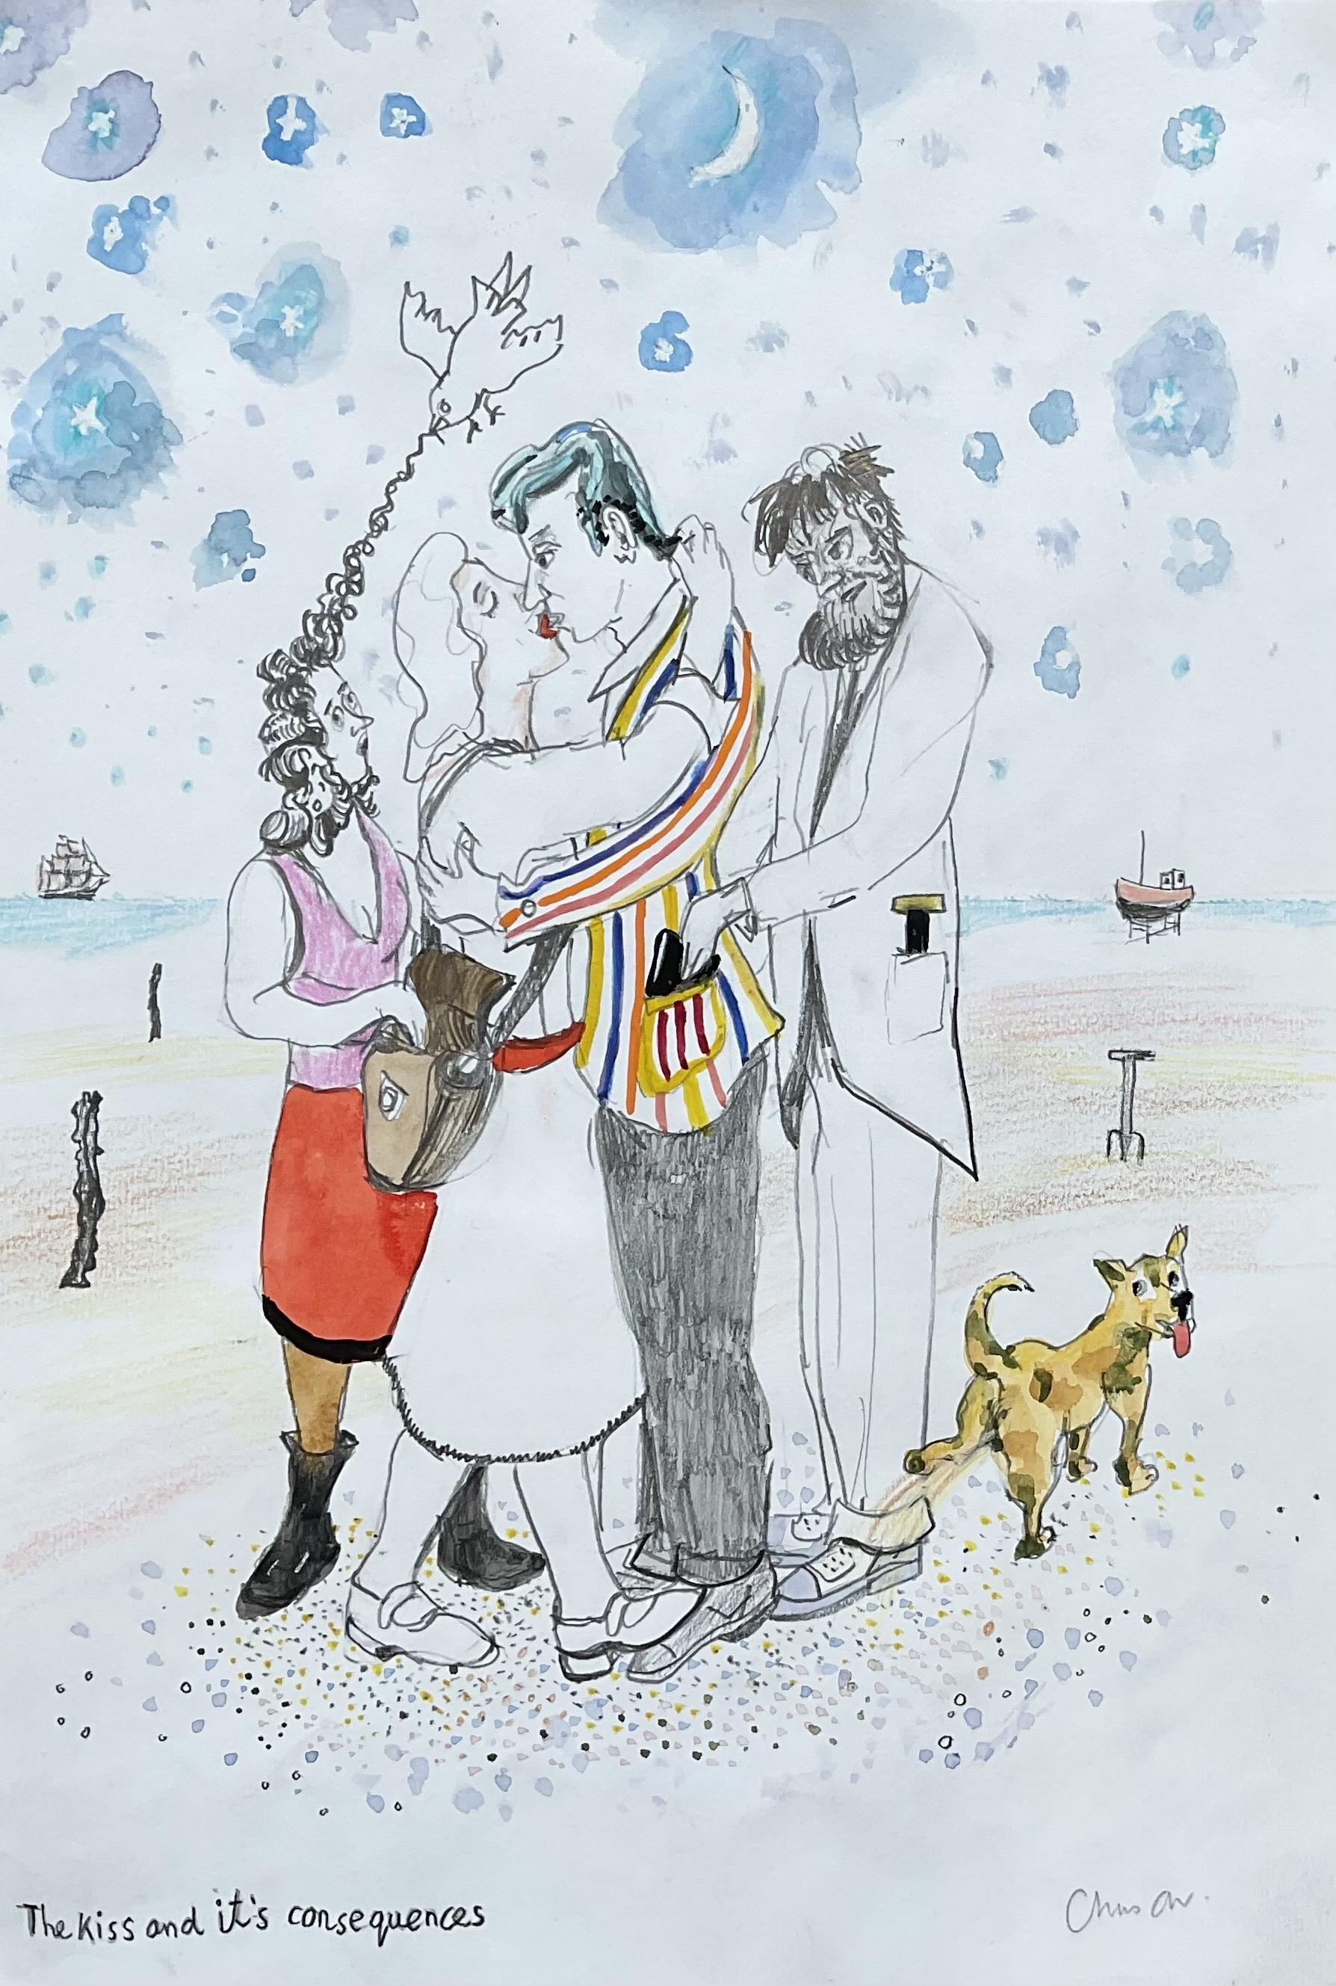
JILL GEORGE GALLERY AT THE CONINGSBY GALLERY OCTOBER 16th to the 28th 2023

“THE KISS AND IT’S CONSEQUENCES”

A celebration of new work by Chris Orr in his 80th year,

One damn thing leads to another and in my painting “The Kiss and its consequences” there are interlocking events out of which nobody comes off well. Maybe the kiss was enough. Most of my work trails through a sequence of incidents which might happen, or which will happen, or which can never happen. On this journey I want the spectator to be challenged and amused. The purpose of my pictures is to relate to the complicated lives we all live. ”The Kiss” is a neat summation of what is going on in the other works in the show.

In my series “Burns and McGonagall” I create an unlikely duo —- my Two Musketeers who get into all sorts of scrapes. They are loosely based on Robert Burns, the Scottish National Poet and William Topaz McGonagall reckoned to be one of the world’s worst poets. Living in different times they never could have met, let alone become chums. McGonagall unfailingly puts his foot in it. Burns is the serious one, although even he has his fling. Each painting is an independent work but the whole series is a kind of visual French Farce exploring ideas from Babysitting to working for Scrooge.

My Icarus paintings are again individual works, although in a series which deals as much with Icarus attempts to get of the ground as getting too near the sun. The interest in Icarus came out of looking closely at the work of Joseph Wright of Derby, whose light filled landscapes seemed to invite Icarus to make an attempt at the sun. I have painted a version of his iconic “Experiment with an air pump” that accord with my passion for pictures that trade in consequences.

My new painting, ”Cargo”, a successor to the recently sold “Ship” deals with the many sided idea of what we carry and send around the world. On the quayside cages of wild animals, mountains of fruit, dancing couples, a collection of cricket bats, bicycles, grandfather clocks and robots prepare to be shipped. Entering the harbour is the “Black Freighter” a ghost ship. De-forestation is going on in the top right side of the painting. This is about the consequences of exploitation.

Another new painting is called “The Human Pyramid”. Icarus arrives at Talent Night and sees many weird and wonderful goings on including the eponymous Human Pyramid. We are all dependant on each other, but at the same time alone. There are many ways to get to the sun.

Every year I make work about places that I have visited and this show will include my “Red roofs of Shimoda” from my trip to Japan in 2022 where I painted a group of new houses with bright red roofs in the small town of Shimoda a couple of hours away from Tokyo. Also there will be my drawing “Uttar Pradesh landscape” and my painting “Beirut 2022”. In these apparently straightforward works there is still an agenda of narrative consequences.

Chris Orr July 2023.

